**Toy Problem**

**Aim :** Create a program to solve a particular toy problem.

**Missionaries and Cannibals**

source=['M','M','M','C','C','C']

boat=[]

dest=[]

print("\nStarting from Source \nSource:",source,"Boat:",boat,"Destination:",dest)

def check(space):

countm,countc=0,0

for i in space:

if(i=='M'):

countm=countm+1

else:

countc=countc+1

if(countm<countc and countm!=0):

if countm+1==countc:

return 1

else: return 2

else:

return False

while(len(source)):

for i in range(2-len(boat)):

boat.insert(i,source.pop())

if(check(source)):

source.append(boat.pop(boat.index('M')))

boat.append(source.pop(source.index('C')))

print("------->")

print("Source:",source,"Boat:",boat,"Destination:",dest)

for i in range(2):

dest.append(boat.pop())

if(check(dest)==2):

boat.append(dest.pop(dest.index('M')))

elif(len(source)==0):

break

else:

boat.append(dest.pop(dest.index('C')))

print("<-------")

print("Source:",source,"Boat:",boat,"Destination:",dest)

print("\nReached Destination: \nSource:",source,"Boat:",boat,"Destination:",dest)

**Output:**

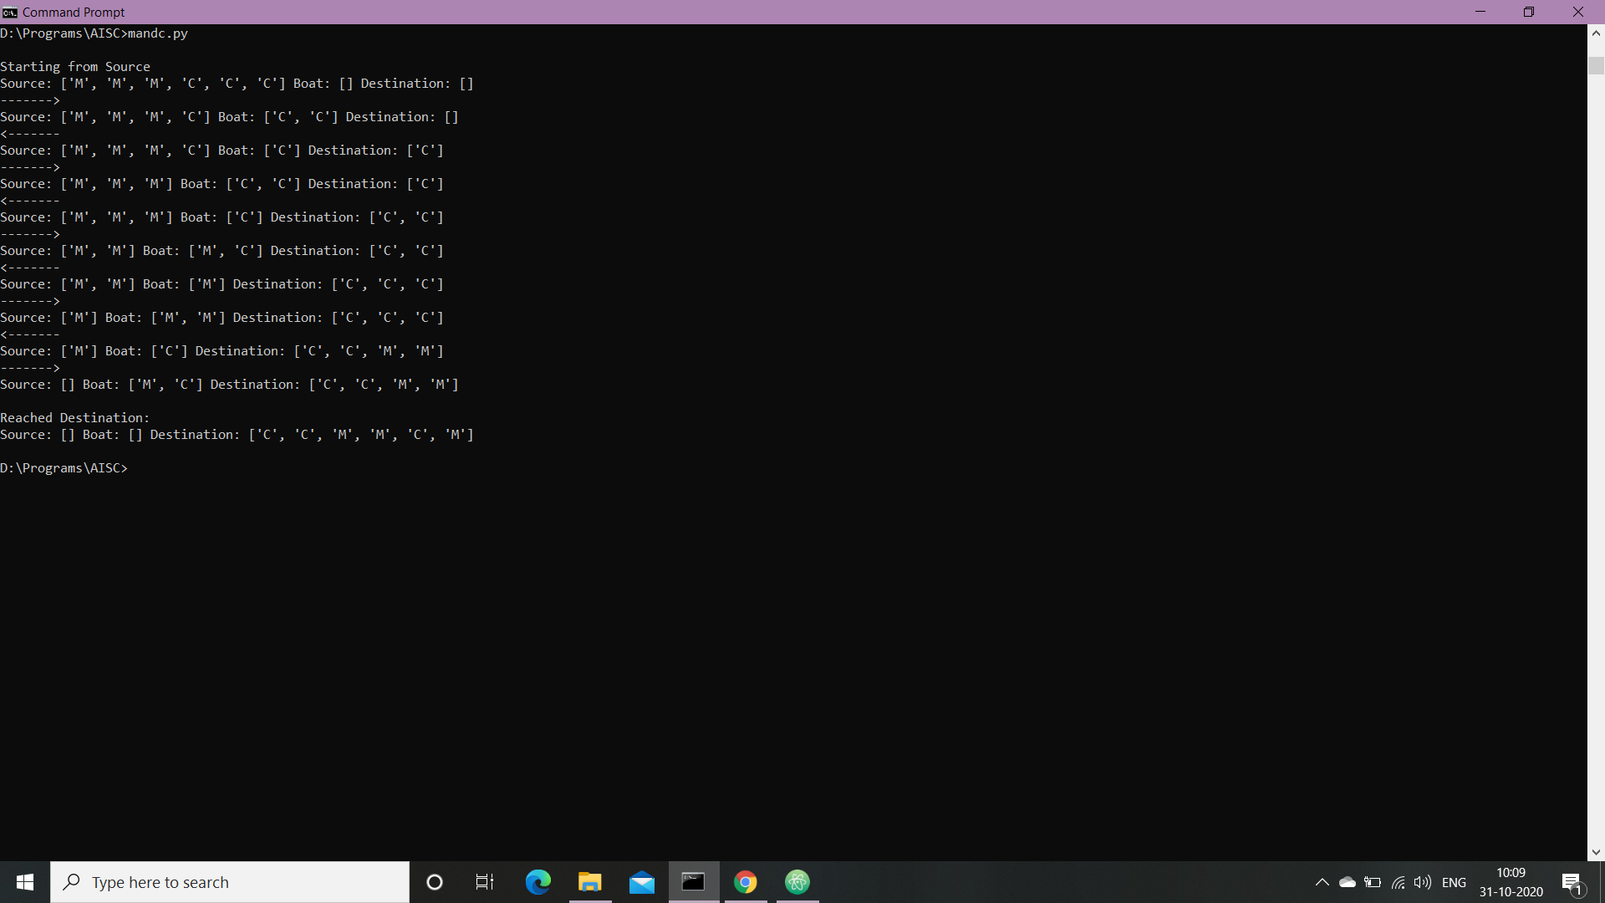

**Conclusion :** Hence, we have successfully solved Missionaries and Cannibals Problem.